- Pa remove na lng po ang submit dish in general since tatanggalin na siya daw po
BOTH ADMIN AND STAFF SIDE
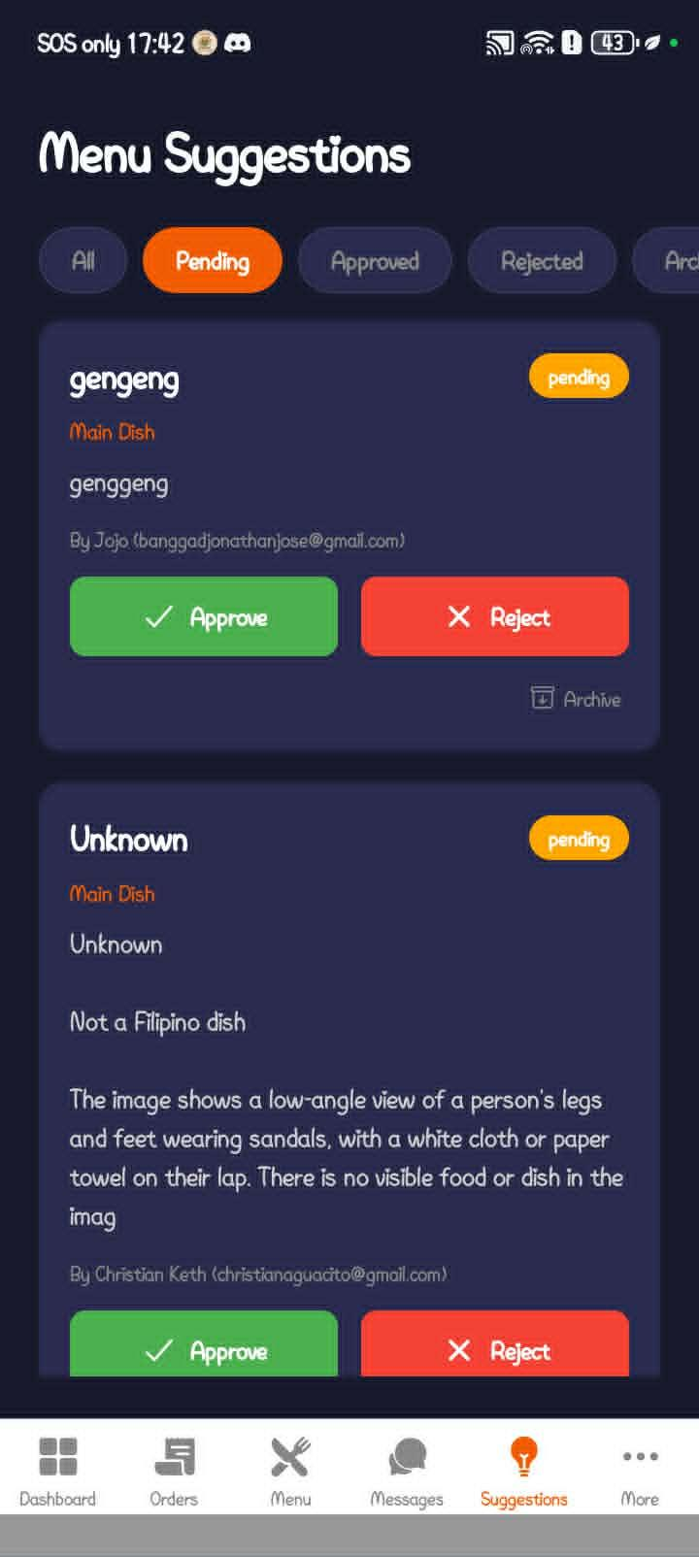

- Yung rider hindi din nakikita sa staff side also sa customer side
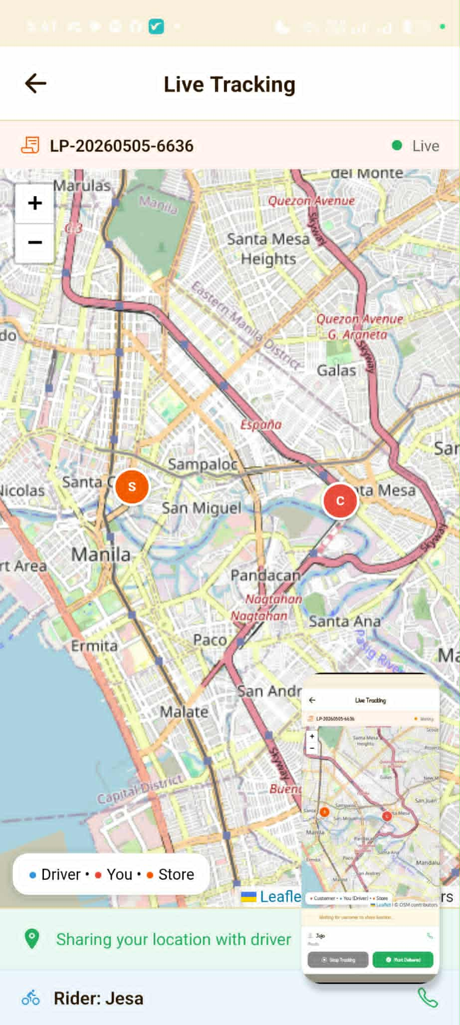

- Yung stocks po di nababawasan even nag order na yung customer
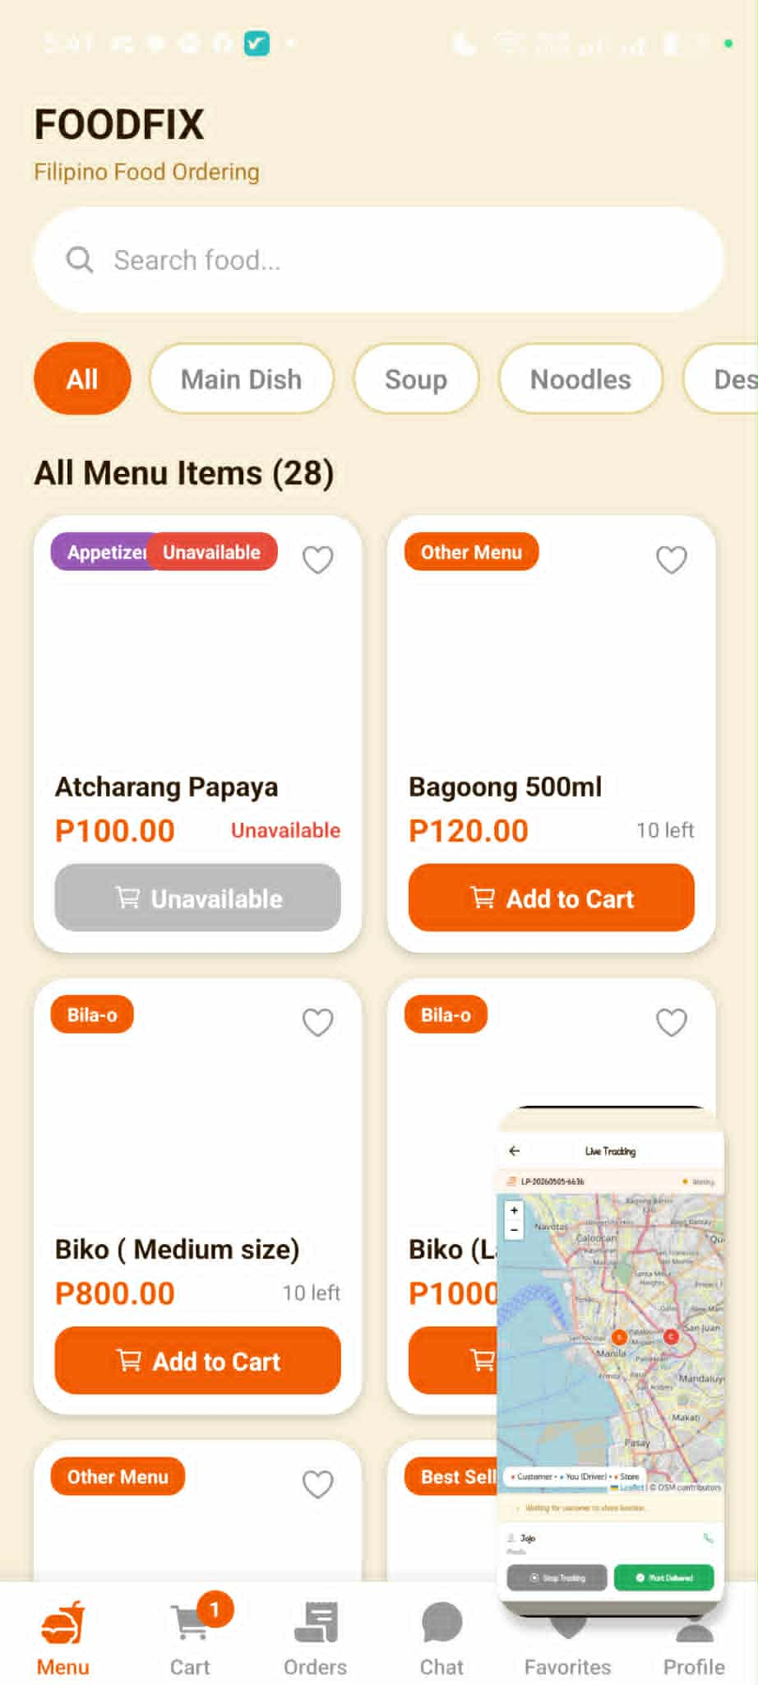

- Hindi gumagana ang delete message sa customer side
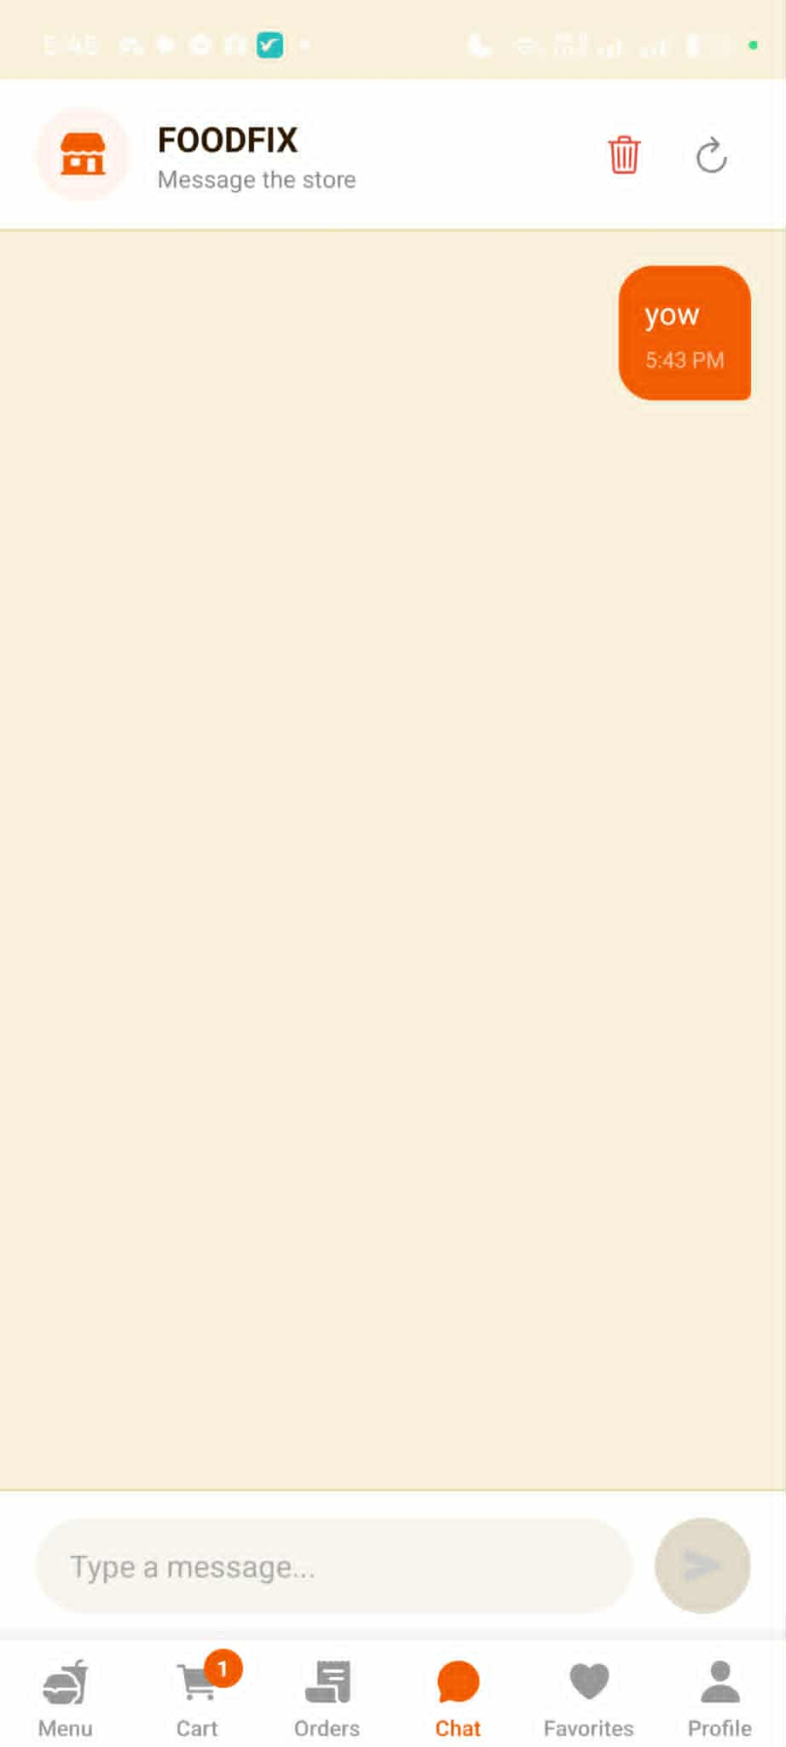

- Hindi gumagana kahit na naka shared location na ang customer sa staff side
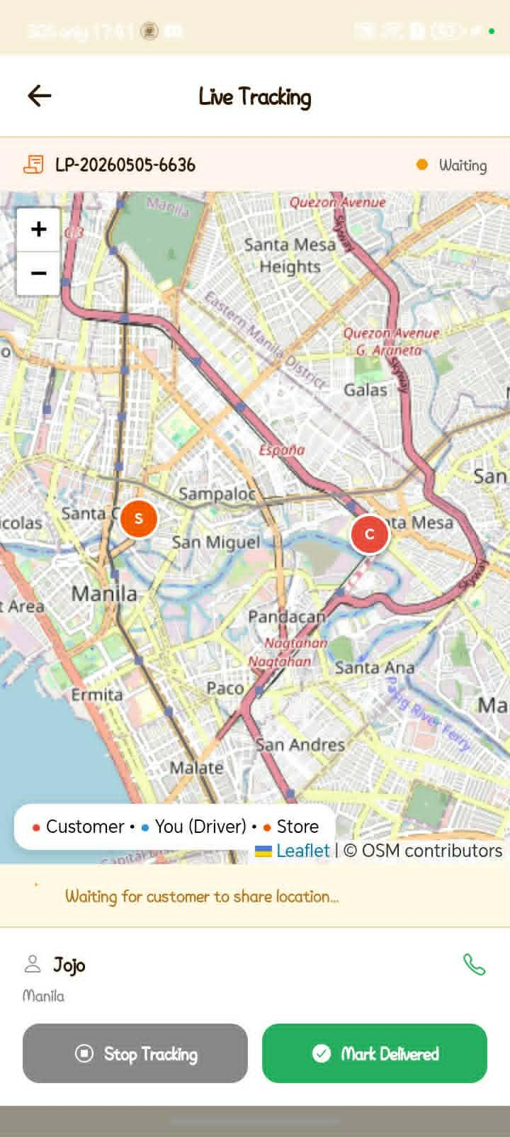

- In general po pag nag delete message may archive din ang archive my 30 days limit bago mag permanently deleted

- In general po sa archived ng order transaction may 30 days limit din po bago mag permanently deleted

- AI name po is FOFI pa change po
- In add to cart, yong time no need to make 24hrs just 1-12 and add am/pm
